School Name:
Principal: Jason McCrevan
School-Site Council Members:
Eric Cline - Parent
Donna Latham - Parent
Diane Cahill - Teacher
Marcie Comtois - Teacher
Laura Katz - Teacher
School / District Mission
The Lowell Public Schools District Vision:
Every Lowell Educator...
· Inspires Learners to Discover and Develop their Talents
· Engages Learners to Think Creatively and Critically
· Empowers Learners to Become Active, Contributing Members of the Community, Our Nation and Our World
The Lowell Public School System Values:
· The Limitless Potential of all Teachers and Students
· School Cultures that are Welcoming, Respectful, Safe, and Healthy
· Collaborative, Professional Growth of Educators Throughout their Careers
· Partnerships with Schools, Families, and the Community
· Equity and Transparency in all our Actions and Interactions
School Vision
Washington Elementary School is committed to providing the conditions and rigor for all students to obtain the essential skills required to become successful, productive citizens in an ever-changing global community.

Core Values/Commitments
We believe:
o all students can learn given the right conditions, time, and support
o all students must be immersed in a safe, respectful, and rich learning community that values and honors diversity
o all students must be developed academically, socially, emotionally, physically, and artistically
o the success of our students is the shared responsibility of the home, school, and community and therefore embrace and encourage support from all constituents of our community
School Motto- Be the Best That You Can Be!
School Strategic Objectives and Initiatives
Leadership, Shared Responsibility, and Professional Collaboration  School leaders make strategic use of staffing, scheduling, and budgeting autonomy to focus on implementing their turnaround plan or other improvement efforts to improve the quality of teaching and learning at the school.  Collective, distributed leadership structures, and practices are apparent throughout the school building in the form of an active, well-represented instructional leadership team and grade-level and vertical teams. Administrators and teachers are jointly committed to and have assumed shared ownership and collective responsibility for improving student achievement. | Intentional Practices for Improving Instruction – Engaged Learning  School leadership has identified a clear instructional focus and shared expectations for instructional best practices that address clearly identified student-specific instructional needs. Administrative observations lead to constructive, teacher-specific feedback, supports, and professional development.  Provide an engaging, rigorous, and relevant program to meet each student's academic, social, and emotional needs. | Student-Specific Supports and Instruction to All Students  The school provides student-specific supports and interventions informed by data and the identification of student-specific needs.  The school employs a system (structures, practices, and use of resources) for providing targeted instructional interventions and supports to all students, including the ongoing monitoring of the impact of tiered interventions and the ability to adapt and modify the school’s structures and resources (e.g., time, staff, schedules) to provide interventions to students throughout the year. | School Climate and Culture  The school has identified and established, and proactively provides effective social-emotional resources and supports and expanded learning opportunities for students in need of such support and assistance.  A climate of respectful collegial  communication, relationships, and  leadership has been established by  leadership, teacher leaders, and teachers,  thus allowing for a positive, productive,  and collective effort to increase family  engagement and student achievement  throughout the school.
English Language Learners  - Develop a school-wide program for English language learner support for all students within staffing constraints focusing on content-driven language learning. | English Language Learners  - Focus on best practices for engaging English language learners within zones of proximal development.  - Implement best practices for teaching ELLs students using the WIDA can-do descriptors.  - Use STEM programs such as ST Math and PLTW to promote engaged learning.  - Align teaching and learning to 2020 WIDA Standards. | English Language Learners  - Based on formative and summative data, we will allocate support staff and tutors to help build English language proficiency. The staffing and teaching models will need to be fluid.  - Hire an additional ELL teacher to target at-need grade levels | English Language Learners  Linguistically diversify our staff to align with the student population.  Help families understand the levels of English proficiency and the steps needed for improvement.
Social-Emotional Learning  - Develop a shared understanding of social-emotional learning.  - Share ownership of Second-Step between the social worker and the classroom teachers.  - Continue learning how to maximize DESSA information and include it as part of the school data dashboard. | Social-Emotional Learning  - Teach all lessons using Second-Step in all grades throughout the year.  - Focus on a common vocabulary of SEL terms and use role-playing to improve these skills. | Social-Emotional Learning  - Connect Second-Step lessons to DESSA lessons to help with interventions for tier II students. | Social-Emotional Learning  - Educate families on the Second-Step program and develop a common vocabulary of standard SEL terms for families to use at home.  - Investigate, fund, and possibly build a playground to help develop unstructured social-emotional learning opportunities
STEM  - Develop a standard definition of STEM/STEAM as a school for all educators.  - Increase time on learning of STEM curriculum and begin the development of interdisciplinary STEM units.  - Year 3 of ST Math:  - The school will identify and train a second ST Math champion.  - Educator Professional development will focus on integrating puzzle talks for tier I instruction.  - Year 1.5 of Project Lead the Way:  - Two teachers will attend summer training related to PLTW.  - The remaining educators will get professional development within the PLTW Launch curriculum. | STEM  - Year 3 ST Math:  - Implementation of ST Math will continue into year 2, with students averaging the grade-appropriate number of puzzles and minutes.  - Year 1.5 Project Lead the Way:  - Grades K-4 will implement at least one unit of study during the first year of the grant. | STEM  Year 3 ST Math:  - Teachers will use the dashboard to target strengths and gaps.  - ST Math data will be analyzed in conjunction with other technology programs to assess the impact on learning. | STEM  - The school will build a STEM/STEAM culture and help define our STEM objectives with all stakeholders’ input. Families will be part of this culture as we include STEM in all learning. Successes will be celebrated with PLTW and ST Math.  Year 3 ST Math:  - The school will continue to build a JiJi / ST math culture to celebrate math successes.  Year 1.5 Project Lead the Way:  - Continue building a STEM/STEAM culture dedicated to engaging and integrated learning for students.  - Implement both programs (ST Math + PLTW), becoming one of the few Mass STEM Hub Schools in the Commonwealth
Family and Community Engagement (FACE)  - The continuation of professional development surrounding family and community engagement practices and cultural competency will continue in collaboration with Dr. Uy from UMASS Lowell. | Family and Community Engagement (FACE) | Family and Community Engagement (FACE)  - Share school and student demographics with families. | Family and Community Engagement (FACE)  - School events will coincide and balance cultural milestones that parallel the community’s diversity.
School Data Profile - As demonstrated below, the Washington School made “Moderate Progress Towards Targets” in the last labeled academic year (2018-2019), the same designation from the 2017-2018 school year. Our student proficiency rates (Meeting or Exceeding Expectations) were 25% in ELA and 24% in Mathematics. These standardized testing results included many opt-out students. Many students also took the exams in a remote setting. The validity of these results should be concerning.

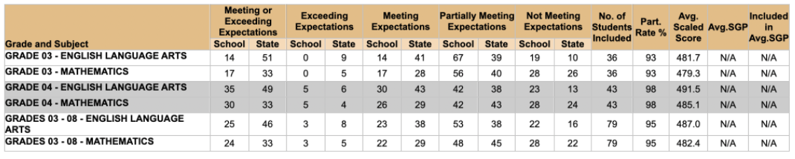
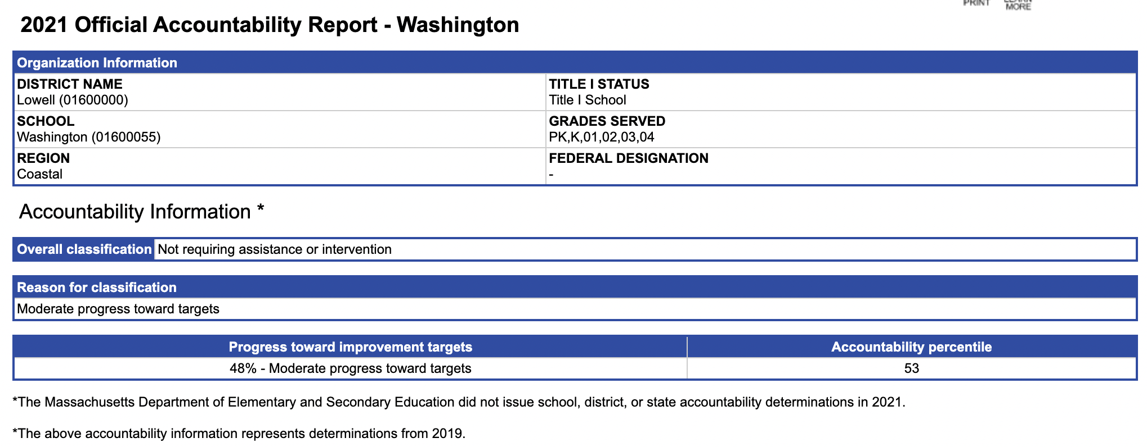
School Demographics: The Washington School enrolls 252 students in Pre-K-fourth grade based on DESE data. The school population consists of a diverse population. (7.3% African-American, 42.7% Asian, 26.4% Hispanic, 17.5% White, and 5.3% Multi-race non-Hispanic. 88.6% of students are high needs, 76.0% Economically Disadvantaged, 42.3% ELL, and 21.1% Special needs). The school also houses a CSA program containing three substantially separate CSA classrooms. An increase in ELLs students has changed enrollment over the past few years at the Washington School.

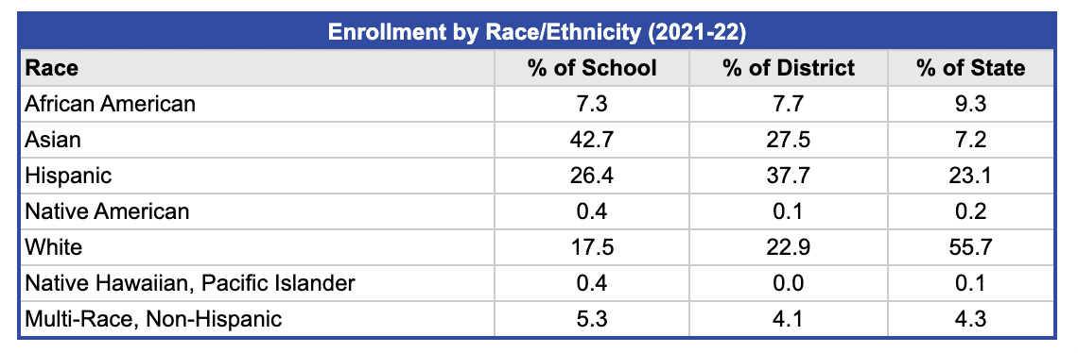
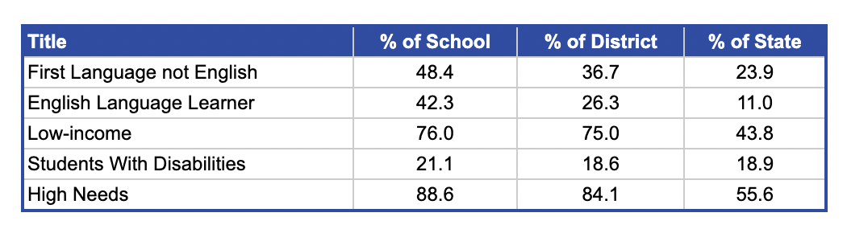

iReady Math - February 2022
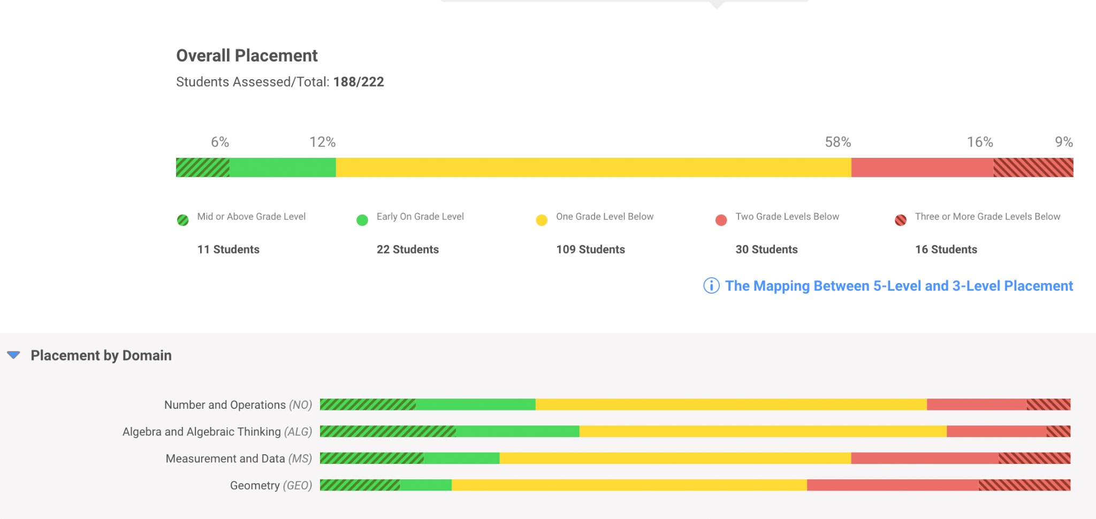
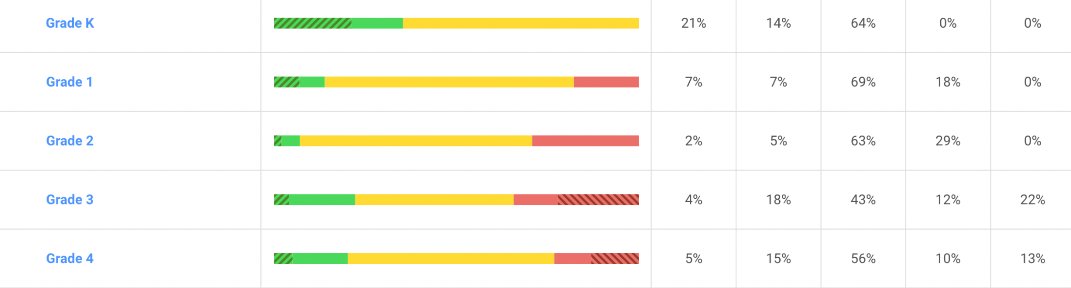
iReady ELA Results - February 2022
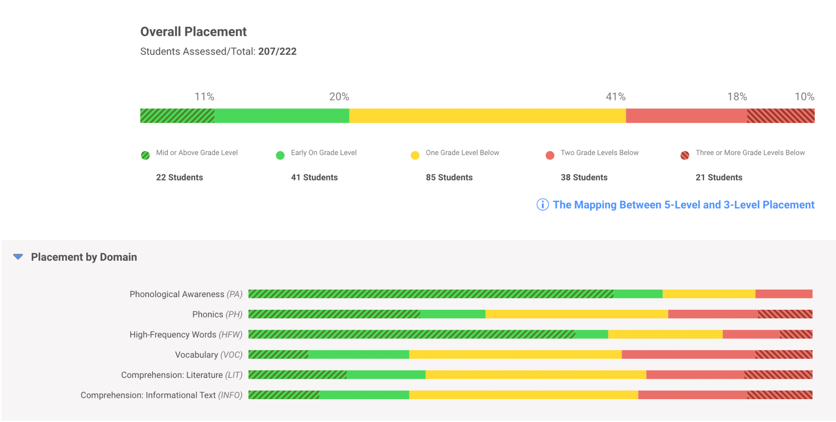

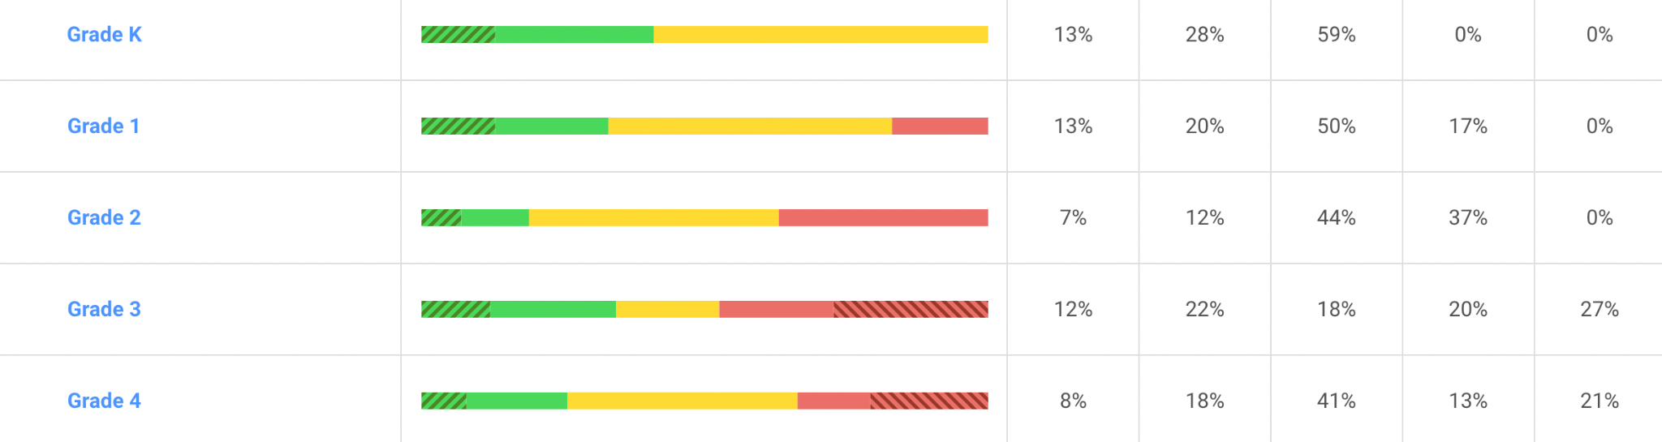
Reflection on Current Practices
- What are your current efforts in targeting school improvement? How can you leverage these efforts when determining school priorities?
Based on our data review, the school has identified the following school goals for our academic growth & progress:

English Language Learners: The data review shows that ELLs students are increasing in population, with almost 50% of the students having a language other than English at home. Our main goal is to increase services for all ELLS students at Washington. One in five students is a newcomer learning English while simultaneously navigating grade-level curriculum. We plan to increase small group support for all students by adding additional ELLs staff with a 1.0 FTE teacher. Our school goal is for 50% of our newcomer students to reach four or above on the ACCESS test. By reaching a four score or greater, the student has developed enough social language to succeed in class. The students will then be ready for the academic language and vocabulary needed for curriculum success.

Social-Emotional Goal: Our long-term goal of adding a full-time Social Worker started this school year. This position helped add services, including social-skills lunch bunches, implementing Second-Step, and giving individualized behavioral and social-emotional support. This position is essential to the school and a priority to maintain. Additionally, for 2022-2023, we wish to focus on balancing the ownership of Second-Step between classroom teachers and the social worker. This allows for additional follow-up lessons to happen. Although we are a small school, we have many social-emotional needs. One goal is to add a mental health support tutor. This tutor would work with the full-time social worker to implement Second Step and meaningfully connect the DESSA screener to SEL instruction. By having the mental health support tutor support the social-emotional program, the social worker can focus more on small group social-skill interventions. The School Site Council is also investigating the need for an on-campus playground structure. Playground structures are essential in building social-emotional skills, teaching children how to cooperate, and building sharing skills. We also see this as an opportunity to strengthen the Washington School community. With most of our students living within walking distance of the school, we see this playground as a valuable resource for the Highlands Community. We wish to use extra funds to complete a proper site specification visit by working with a professional playground specialist. We are investigating this proposal with the City of Lowell Parks and Recreation Department.

STEM: Quantitative and qualitative data from students, teachers, and the School Site Council shows that STEM learning opportunities are engaging for all students. Forty-two percent of our students want us to teach more science. Forty-one percent of the students say science is their favorite subject. To prioritize STEM learning, the school needs to build a better understanding of STEM. A common definition and understanding of STEM will be the focus of professional development for teachers and students. Programmatically we will target the first full year of implementation with Project Lead the Way by teaching at least one unit in grades K-4 and training another lead teacher. In ST Math, we will target professional development using Puzzle Talks for tier I instruction and reviewing data to inform and drive intervention and instruction. Another necessary goal is to increase STEM learning time in the master schedule for all grade levels.

Student Survey November 2020
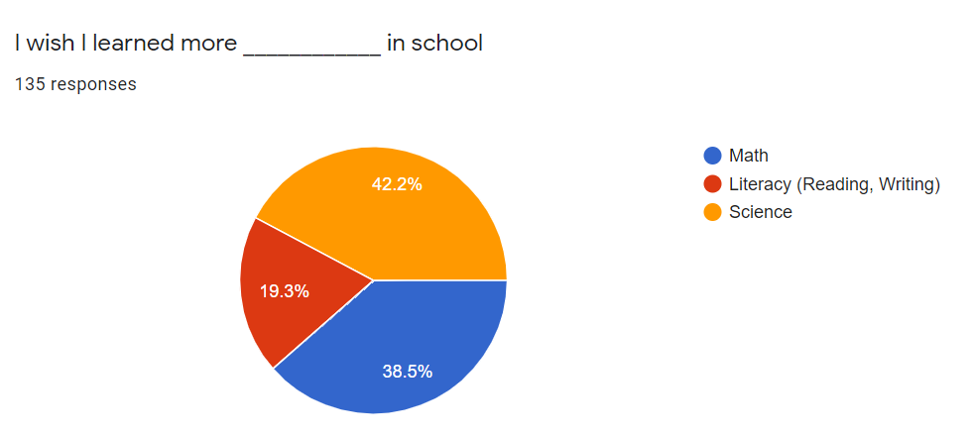
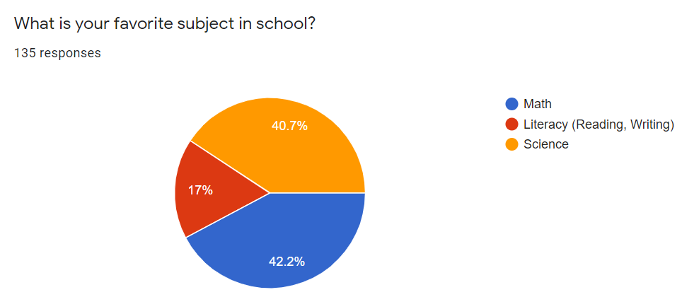

Family and Community Engagement (FACE):
Our continuing goal of building and sustaining FACE at Washington will enter year three with professional development from Dr. Uy from UMASS Lowell. Our professional development will work on refining translation services, building a school community centered on understanding teaching and learning, and establishing a culturally appropriate events calendar.

- What progress is your school making towards academic goals? What is data saying the priorities should be? Where there is not desired progress, what is holding up momentum that should be addressed?
The school currently earned the 53% Accountability Rating within the Commonwealth of Massachusetts based on the 2019 MCAS. Localized results show gaps, but we should remain cautious of the pandemic results.
ELA: Although we hypothesized that the pandemic greatly impacted foundational skills, the comprehension skills and vocabulary need the most support. Seventy-two percent of our students are at least one grade level under expectations as of March 2022. Comprehension of literature and informational text and vocabulary had the highest levels of tier three students. Vocabulary development continues to be a challenge with such a large population of ELLs learners.
Math: Although mathematics achievement was strong in MCAS in previous years, the localized results have identified several areas of concern. Grades one and two need the most support, with only 14% and 7% proficient or above. Although we are lower in some math strands over others, a focus on number sense needs to occur. Foundational skills are needed to progress effectively. We should cross-reference ST Math results with iReady results to gauge the effectiveness of this intervention during year three. These decisions will help us decide on using ST Math once the grant ends after the 2022-2023 school year.
- Where are students making the greatest academic gains and why? The least academic gains and why?
ELA: Grades 1-2 need additional support going forward with ELA. Basic literacy skills, including phonological awareness, high-frequency words, and phonics, were learned best this school year. iReady results show that vocabulary and comprehension skills need the most support. The students’ academic language acquisition is a significant concern. Students know how to sound out the words but lack the meaning of the vocabulary while still trying to master the English language.
Math: We have few areas to highlight in mathematics this year. Although ST Math assignments seem on pace, these results did not translate to iReady scores. Math instruction struggled during the pandemic. Focusing on number sense will be the priority for the 2022-2023 school year. We also have to connect ST Math as an instructional method, rather than just relying on it as an intervention. Using ST Math as a core instruction piece with puzzle talks will better balance the conceptual knowledge with the actual arithmetic.

Monitoring Progress - Process Benchmarks
What will be done, when, and by whom
Leadership, Shared Responsibility, and Professional Collaboration | Person Responsible | Aug 2022 | Dec 2022 | June 2023 | Status
ST Math - Train a second math champion, integrate puzzle talks, increase STEM time on learning | Educators, Principal, ST Math Champions
Project Lead the Way - Train two lead teachers in the Launch curriculum | Educators, Principal, Project Lead the Way Lead Teachers
English Language Learners - develop a schoolwide plan for supporting ELLs with three ELLs teachers | Principal, Literacy Specialist, Educators, District ELLs Director
Family and Community Engagement - continue PD with the support of Dr. Uy. | Educators, District Equity Coordinator, Outside Consultant, Principal, Educators
Social Emotional Learning - hire an additional SEL tutor to support Second-Step and DESSA. | District Leadership, Principal, Social Worker
Intentional Practices for Improving Instruction – Engaged Learning | Person Responsible | Aug 2022 | Dec 2022 | June 2023 | Status
ST Math - meet ST Math requirements for puzzles and minutes | Educators, Principal, ST Math Champions
Project Lead the Way - each classroom (K-4) will implement at least one PLTW unit | Educators, Principal, Project Lead the Way Lead Teachers
English Language Learners - connect learner to WIDA best practices | Principal, Literacy Specialist, Educators, District ELLs Director
Family and Community Engagement -develop a culturally responsive events’ calendar | Educators, District Equity Coordinator, Outside Consultant, Principal, Educators
Social Emotional Learning - teach all Second Step lessons, develop common vocabulary of social emotional learning totals | District Leadership, Principal, CFO, Social Worker
Student-Specific Supports and Instruction to All Students | Person Responsible | Aug 2021 | Dec 2021 | June 2021 | Status
ST Math - use the dashboard to inform teaching and learning, assess effective by comparing results with other assessments | Educators, Principal, ST Math Champions, Math Lead Teacher
Project Lead the Way -use student science journals to catalog learning more authentically | Educators, Principal, Project Lead the Way Lead Teachers
English Language Learners - allocate staff appropriately and fluidly to support ELLs learning | Principal, Literacy Specialist, Educators, District ELLs Director
Family and Community Engagement - develop and analyze a demographics and learning data profile | Educators, District Equity Coordinator, Outside Consultant, Principal, Educators
Social Emotional Learning - allocate staff appropriately to extinguish opportunity and learning gaps | District Leadership, Principal, CFO, Social Worker
School Climate and Culture | Person Responsible | Aug 2022 | Dec 2022 | June 2023 | Status
ST Math - build a JiJi culture celebrating success and include families | Educators, Principal, ST Math Champions
Project Lead the Way - promote being a Massachusetts STEM Hub School, building a school engineering culture | Educators, Principal, Project Lead the Way Lead Teachers
English Language Learners - continue communicating by the families preferred means, help families understand levels of English language proficiency | Principal, Literacy Specialist, Educators, District ELLs Director
Family and Community Engagement - balance outside of school events to match family cultures, make parent conferences more meaningful | Educators, District Equity Coordinator, Outside Consultant, Principal, Educators
Social Emotional Learning - educate families on the vocabulary and value of the Second Step program | District Leadership, Principal, CFO, Social Worker

Measuring Impact
Changes in practice, attitude, or behavior when the initiative is having its desired impact. Desired Targets.
Leadership, Shared Responsibility, and Professional Collaboration | Person Responsible | Date | Status
ST Math - Train a second math champion, integrate puzzle talks, increase STEM time on learning | Educators, Principal, ST Math Champions
Project Lead the Way - Train two lead teachers in the Launch curriculum | Educators, Principal, Project Lead the Way Lead Teachers
English Language Learners - develop a schoolwide plan for supporting ELLs with three ELLs teachers | Principal, Literacy Specialist, Educators, District ELLs Director
Family and Community Engagement - continue PD with the support of Dr. Uy. | Educators, District Equity Coordinator, Outside Consultant, Principal, Educators
Social Emotional Learning - hire an additional SEL tutor to support Second-Step and DESSA. | District Leadership, Principal, Social Worker
Intentional Practices for Improving Instruction – Engaged Learning | Person Responsible | Date | Status
ST Math - meet ST Math requirements for puzzles and minutes | Educators, Principal, ST Math Champions
Project Lead the Way - each classroom (K-4) will implement at least one PLTW unit | Educators, Principal, Project Lead the Way Lead Teachers
English Language Learners - connect the learner to WIDA best practices | Principal, Literacy Specialist, Educators, District ELLs Director
Family and Community Engagement -develop a culturally responsive events’ calendar | Educators, District Equity Coordinator, Outside Consultant, Principal, Educators
Social Emotional Learning - teach all Second Step lessons, develop a common vocabulary of social emotional learning totals | District Leadership, Principal, CFO, Social Worker
Student-Specific Supports and Instruction to All Students | Person Responsible | Date | Status
ST Math - use the dashboard to inform teaching and learning, assess effective by comparing results with other assessments | Educators, Principal, ST Math Champions, Math Lead Teacher
Project Lead the Way -use student science journals to catalog learning more authentically | Educators, Principal, Project Lead the Way Lead Teachers
English Language Learners - allocate staff appropriately and fluidly to support ELLs learning | Principal, Literacy Specialist, Educators, District ELLs Director
Family and Community Engagement - develop and analyze a demographics and learning data profile | Educators, District Equity Coordinator, Outside Consultant, Principal, Educators
Social Emotional Learning - allocate staff appropriately to extinguish opportunity and learning gaps | District Leadership, Principal, CFO, Social Worker
School Climate and Culture | Person Responsible | Date | Status
ST Math - build a JiJi culture celebrating success and include families | Educators, Principal, ST Math Champions
Project Lead the Way - promote being a Massachusetts STEM Hub School, building a school engineering culture | Educators, Principal, Project Lead the Way Lead Teachers
English Language Learners - continue communicating by the families preferred means, help families understand levels of English language proficiency | Principal, Literacy Specialist, Educators, District ELLs Director
Family and Community Engagement - balance outside of school events to match family cultures, make parent conferences more meaningful | Educators, District Equity Coordinator, Outside Consultant, Principal, Educators
Social Emotional Learning - educate families on the vocabulary and value of the Second Step program | District Leadership, Principal, CFO, Social Worker

